**Critical Thinking**

**Tutorial 6: Assessing and evaluating complex arguments**

***Jennifer M. Windt***

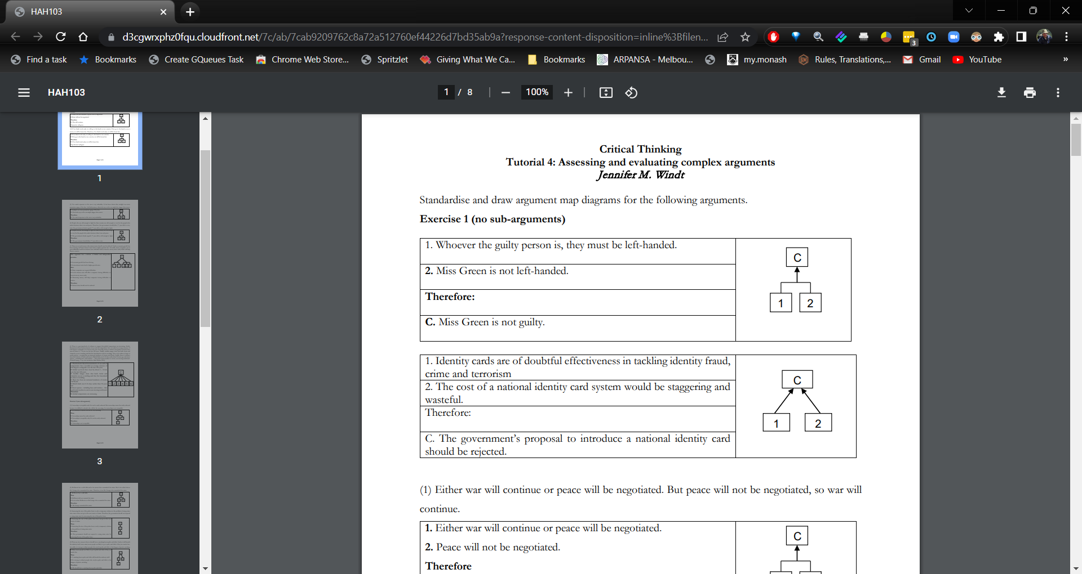

(1) Either war will continue or peace will be negotiated. But peace will not be negotiated, so war will continue.

(2) If we finish work early, we will go to the beach or see a movie. If we go to the beach or see a movie, we will be home late. Therefore, if we finish work early, we will be home late.

(3) Too much exposure to the sun is very unhealthy. It has been shown that sunlight can cause premature ageing of the skin. And furthermore, ultraviolet rays in the sun might also trigger skin cancer.

(4) People who are old enough to fight for their country are old enough to vote for the people who make decisions about war and peace. Therefore, this government should allow 17 year olds to vote, since the government clearly regards 17 year olds as old enough to fight.

(5) There are several reasons why interest rates should now be reduced. Firstly, economic growth has been slowing and lower interest rates lead to higher growth rates. Secondly, many companies are in great difficulties and lower interest rates will allow them to borrow money more easily which will help them to survive.

Independent

P1. economic growth has been slowing

Therefore,

P2. lower interest rates lead to higher growth rates

P3. many companies are in great difficulties and lower interest rates will allow them to borrow money more easily which will help them to survive

Therefore,

interest rates should now be reduced

(6) There is a growing body of evidence to suggest that global temperatures are increasing. Firstly, thermometer-based measurements of sea and air temperatures have recorded an average increase of 0.65 degrees centigrade over the last 130 years. Secondly, there is evidence that global sea-levels have risen by about 4 – 14 cm over the last 100 years. Thirdly, satellite images show that both Arctic and Antarctic sea ice is melting and that the Greenland ice-sheet is receding. There is also evidence of changes in weather patterns – in particular, an increased incidence of storms and floods. Finally, there is evidence from the behavior of birds and insects: British birds nest 8-16 days earlier than 30 years ago and insect species – including bees and termites – that need warm weather to survive are moving northward. (*Global Warming: A very short introduction*. Mark Maslin, 2004)

**Exercise 2 (one sub-argument)**

**Example:**

1. Smith was alive when Hallett left and died later of drowning when the tide came in.

Therefore:

2. Hallett did not cause Smith’s death.

3. For a person to be guilty of murder, it must be shown that their actions caused the death of another person.

Therefore:

C. Hallett is not guilty of murdering Smith

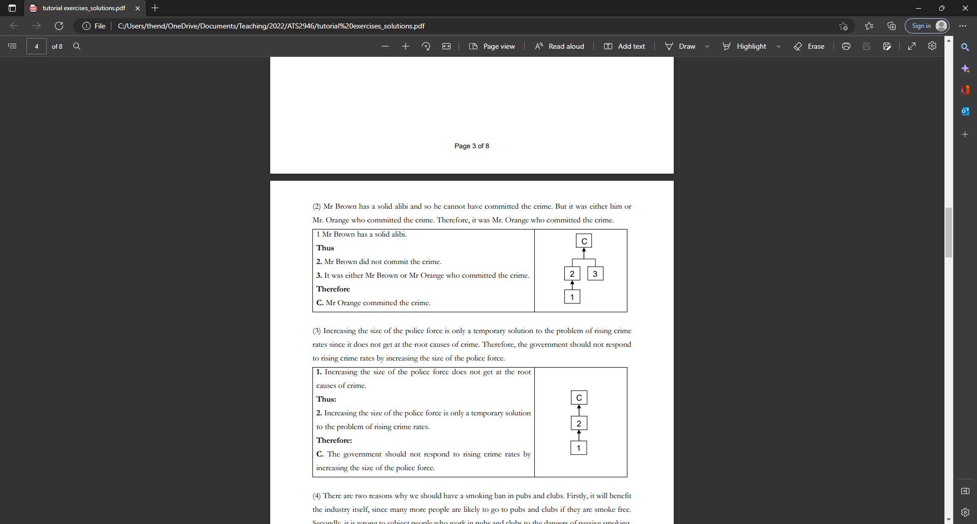

(1) Censorship is acceptable only if it can be easily enforced. But censorship cannot be easily enforced because it is difficult to decide who will do the censoring. So censorship is not acceptable.

1. Censorship is acceptable only if it can be easily enforced
2. it is difficult to decide who will do the censoring

Therefore,

Therefore,

censorship is not acceptable.

(2) Mr Brown has a solid alibi and so he cannot have committed the crime. But it was either him or Mr. Orange who committed the crime. Therefore, it was Mr. Orange who committed the crime.

P1. it was either him or Mr. Orange who committed the crime

P2. Mr Brown has a solid alibi

Therefore,

P3. he cannot have committed the crime

Therefore,

Mr. Orange who committed the crime.

(3) Increasing the size of the police force is only a temporary solution to the problem of rising crime rates since it does not get at the root causes of crime. Therefore, the government should not respond to rising crime rates by increasing the size of the police force.

P1. Increasing the size of the police force does not get at the root causes of crime.

Therefore,

P2. Increasing the size of the police force is only a temporary solution to the problem of rising crime rates.

Therefore,

The government should not respond to rising crime rates by increasing the size of the police force.

(4) There are two reasons why we should have a smoking ban in pubs and clubs. Firstly, it will benefit the industry itself, since many more people are likely to go to pubs and clubs if they are smoke free. Secondly, it is wrong to subject people who work in pubs and clubs to the dangers of passive smoking.

P1. if they are smoke free, many more people are likely to go to pubs and clubs

Therefore,

P2. It will benefit the industry itself

P3. people work in pubs and clubs to the dangers of passive smoking (Independent)

Therefore,

we should have a smoking ban in pubs and clubs

(5) Radioactive elements disintegrate and eventually turn into lead. Hence, if matter has always existed there should be no radioactive elements left. But there is still plenty of uranium and other radioactive elements around. This is scientific proof that matter has not always existed.

P1. Radioactive elements disintegrate and eventually turn into lead.

Therefore,

P2. if matter has always existed there should be no radioactive elements left

P3. still plenty of uranium and other radioactive elements around

Therefore,

…

(6) If many people lose their homes, the real estate market will deteriorate. And if that happens, the construction industry will slow down. So, if many people lose their homes, the construction industry will slow down. Recent figures show that many people are losing their homes. Therefore, the construction industry will slow down.

P1, If many people lose their homes, the real estate market will deteriorate

P2, if that happens, the construction industry will slow down

Therefore,

P3, if many people lose their homes, the construction industry will slow down

P4, many people are losing their homes

Therefore,

the construction industry will slow down

**Exercise 3 (Several sub-arguments)**

(1) The speed limit on major highways should not be reduced. Professional drivers spend much more time driving, on average, than do other people and hence they are more competent drivers than are other, less experienced drivers. So reducing the speed limit would have the undesirable effect of forcing some people who are now both law abiding and competent drivers to break the law.

P1, Professional drivers spend much more time driving, on average, than do other people

Therefore,

P2, they are more competent drivers than are other, less experienced drivers

Therefore,

P3, reducing the speed limit would have the undesirable effect of forcing some people who are now both law abiding and competent drivers to break the law.

Therefore

speed limit on major highways should not be reduced

(2) … Sociologically, however, it may be argued that crime is both normal and necessary. Crime is ‘normal’ in the sense that if we look at all societies, past and present, we always find criminal or ‘deviant’ behaviour which meets with some form of punishment or sanction. Crime is ‘necessary’ in the sense that any behaviour we define as punishable also serves to define the boundaries of what is acceptable and unacceptable behaviour, and that such boundary definition is fundamental to social order.

(3) The kidnapper must have gone either east or west along the road or north or south across country. But we know he did not go east along the road because a policeman was on duty in that direction all night and he says he saw no one. And we know he did not go west because the people at the inn to the west were awake all night, waiting for a doctor to arrive and they also saw no one. So the kidnapper must have gone north or south across country. But he cannot have gone south since he took the bicycle and the country to the south is impossible to cross with a bicycle. Therefore, the kidnapper must have gone north. (Adapted from the Sherlock Holmes story: *The Priory* *School*)

(4) The proposed dam on the Merv River should not be built. Although the dam would provide irrigation for the dry land in the upstream areas, it would reduce agricultural productivity in the fertile land downstream, since the availability and quality of water downstream from the dam would be reduced. The productivity loss in the downstream area would be greater than the productivity gain upstream, so the dam would yield no overall gain in agricultural productivity in the region as a whole.

**The philosophical argument of the week**

“A dominant role in nearly all recent inquiries into the free-will problem has been played by a principle which I X J L shall call "the principle of alternate possibilities." This principle states that a person is morally responsible for what he (sic) has done only if he could have done otherwise…

But the principle of alternate possibilities is false. A person may well be morally responsible for what he has done even though he could not have done otherwise…

Suppose someone, Black, let us say wants Jones to perform a certain action. Black is prepared to go to considerable lengths to get his way, but he prefers to avoid showing his hand unnecessarily. So he waits until Jones is about to make up his mind what to do, and he does nothing unless it is clear to him (Black is an excellent judge of such things) that Jones is going to decide to do something other than what he wants him to do. If it does become clear that Jones is going to decide to do something else, Black takes effective steps to ensure that Jones decides to do, and that he does do, what he wants him to do. Whatever Jones's initial preferences and inclinations, then, Black will have his way....

Now suppose that Black never has to show his hand because Jones, for reasons of his own, decides to perform and does perform the very action Black wants him to perform. In that case, it seems clear, Jones will bear precisely the same moral responsibility for what he does as he would have borne if Black had not been ready to take steps to ensure that he do it. It would be quite unreasonable to excuse Jones for his action, or to withhold the praise to which it would normally entitle him, on the basis of the fact that he could not have done otherwise.” (Harry Frankfurt (1969), Alternate Possibilities and Moral Responsibility, *Journal of Philosophy* 45, 829-839).

What is the argument supposed to show? What is its main conclusion?

Can you reconstruct Frankfurt’s argument?

**Discussion question of the week:**

Now, think about Frankfurt’s strategy. How does the example of Black and Jones fit in with the different kinds of arguments that we have discussed so far? Is this an effective kind of argument, and why/why not?